**PROJECT REPORT**

**Table of Contents**

|  |  |  |
| --- | --- | --- |
| **Sr No.** | **Contents** | **Page No.** |
| **1.** | **Diwali Sales Analysis** | **1** |
| **2.** | **Objective and Scope of the project** | **1** |
| **3.** | **Resources Used** | **2** |
| **4.** | **Project Schedule Plan** | **3** |
| **5.** | **Project Teams** | **4** |
| **6.** | **Process Description** | **4** |
| **7.** | **Contribution of the Student in project** | **4** |
| **8.** | **Conclusion** | **5** |
| **9.** | **Project Screenshots** | **6-7** |
| **10.** | **Bibliography** | **8** |

**Diwali Sales Analysis**

**INTRODUCTION**

**Diwali Sales Analysis** is the method of exploring and analyzing sales data recorded or collected over a ***set period of time***. This technique is used to analyze values and give analysis based on gender, product, state and their orders.

Diwali sales analysis gives a way to analyze the future. It is essential in engineering, finance, business, and the economy to make it easy for investors, customers, or engineers to make the proper decisions.

For analysing data ,here we use two different tools:

1. **Matplotlib:** Matplotlib is a versatile and powerful tool for data visualization in Python and is commonly used for tasks ranging from simple exploratory data analysis to creating complex, publication-ready figures. It provides users with the flexibility to create visuals that suit their specific needs, making it a valuable asset for data scientists, researchers, and analysts.
2. **Seaborn:** Seaborn is an excellent choice for data analysts and scientists who want to create visually appealing and informative plots with minimal effort. It simplifies the process of creating complex statistical visualizations and enhances the quality of data exploration and presentation. Its integration with Pandas and Matplotlib makes it a valuable addition to the Python data visualization ecosystem.

**2. OBJECTIVES AND SCOPE**

Our main objective is to analysis on diwali sales data and give insights in a webpage.

There are two main goals of diwali sales analysis:

* *Analysis on sales data*.
* *Give insights in a webpage.*

**Scope**

Diwali Sales Analysis is used in ecommerce to give insights the market trends during sales. Small Stores also use these insights to analyze sales and units sold for different products.

1. **Resources (Hardware & Software)**
2. **Hardware Requirements**

**Client Side**

|  |  |
| --- | --- |
| Processor | Dual Core or above |
| RAM | 1 GB |
| Disk space | 150 GB |
| Screen Resolution | 1080p or less |
| Others | Keyboard, mouse, Internet Connection |

**Server Side**

|  |  |
| --- | --- |
| Processor | Dual Core or above |
| RAM | 1 GB |
| Disk space | 150 GB |
| Screen Resolution | 1080p or less |
| Others | Keyboard, mouse, Internet Connection |

1. **Software Requirements**

**Client Side**

* Web Browser (Google Chrome, Firefox, Edge or above)
* Windows 7 or above / Linux / Android / IOS

**Server Side**

* Web Browser (Google Chrome, Firefox, Edge or above)
* Windows 7 or above / Linux / Android / IOS
* VScode
* Python 3.9 and Html, CSS, Bootstrap

**4. Project Schedule Plan:**

The objective of Software Planning is to provide a framework that enables the manager to make reasonable estimates of resources, cost, and schedule. These estimates are made within a limited time frame at the beginning of a software project and should be updated regularly as the project progresses. In addition, estimates should attempt to define best case and worst case scenario so that project outcomes can be bounded.

A Gantt chart is a popular type of chart that illustrates a project schedule. Gantt Chart illustrates the start and finish dates of the terminal elements and summary elements of a project. Terminal element and summary comprise the work breakdown structure of the project.

|  |  |  |  |  |  |  |
| --- | --- | --- | --- | --- | --- | --- |
| Task | 01Oct-03Oct | 04Oct-05Oct | 06Oct-07OCt | 08Oct-09Oct | 09Oct-10Oct | 10Oct-11Oct |
| Develop project proposal | 03 days |  |  |  |  |  |
| Analysis |  | 2 days |  |  |  |  |
| Designing |  |  | 2 days |  |  |  |
| Coding |  |  |  | 2 days |  |  |
| Unit Testing |  |  |  |  | 1 day |  |
| Implementation |  |  |  |  |  | 1 day |

**Gantt Chart**

**5. Project Team:**

**Instructor :** Narendra Jha Sir

**Project Team Members :** Ayush Srivastava

Gaurav Tiwari

Pranjal Mishra

**6. Process Description**

1. **Data pre-processing:** This module is used to analyse the data, checks its validity and removes the incorrect data. Make the data in format for further analysis.
2. **Data Analysis:** This module defines different types of graphical representation for the sales. It gives the user flexibility to represent data in different graphical form.
3. **View Display:** This module shows the output insights to user. It’s a webpage to view insights according to analysis on sales. User is here small businesses, whole sellers, startups.

**7. Contribution of the student in the project:**

1. **Ayush Srivastava:** Data Preprocessing.
2. **Pranjal Mishra:** Exploratory Data Analysis.
3. **Gaurav Tiwari:** View Display.

**8. Conclusion:**

* At the end businesses have an idea about their sales according to orders and products using diwali sales analysis.
* Diwali remains a crucial period for businesses to boost sales, with a significant impact on annual revenue.
* The shift towards e-commerce, the popularity of certain product categories, and effective marketing strategies are some of the key factors driving success during this festive season.
* Understanding regional variations and evolving consumer’s behaviour is essential for businesses looking to capitalize on the Diwali sales opportunity.
* Additionally, sustainability and eco-friendliness are emerging as important considerations for both retailers and consumers during this festive season.

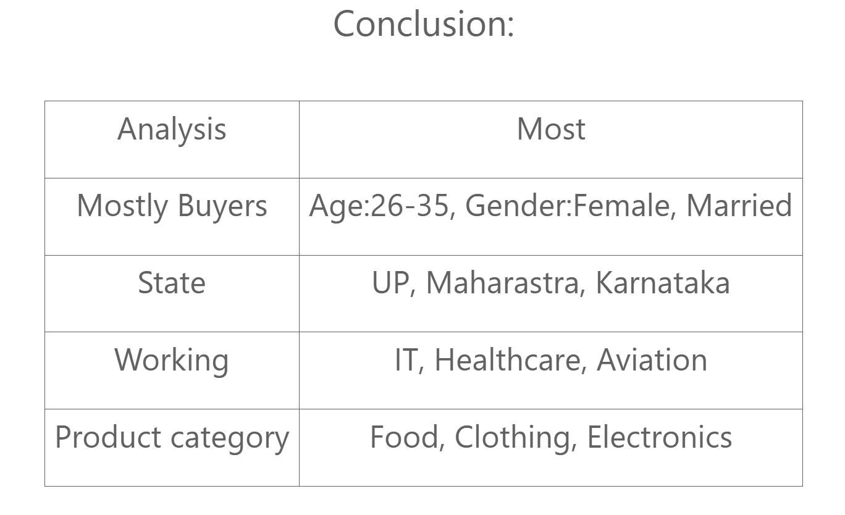

**9. Project Screenshots:**

**Data Preprocessing:**

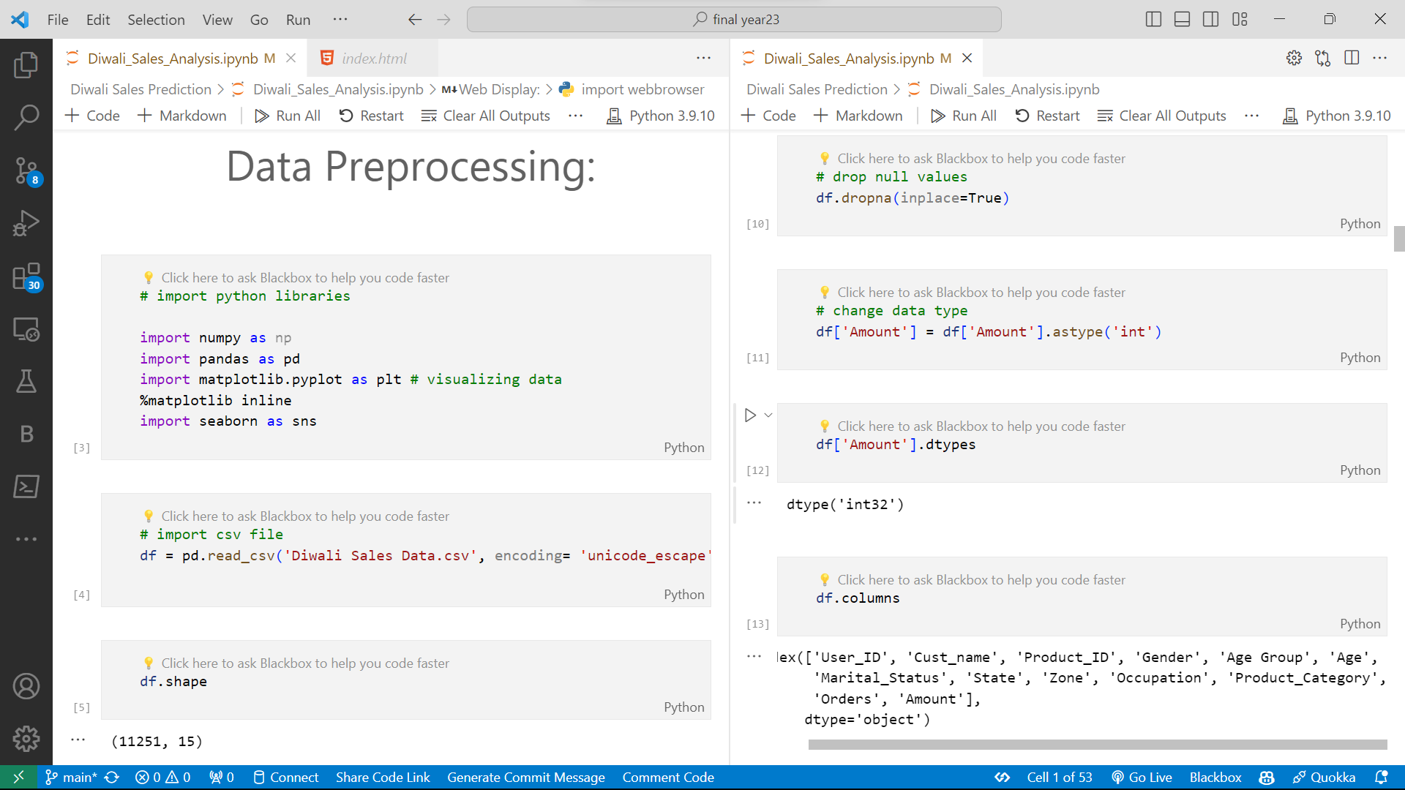

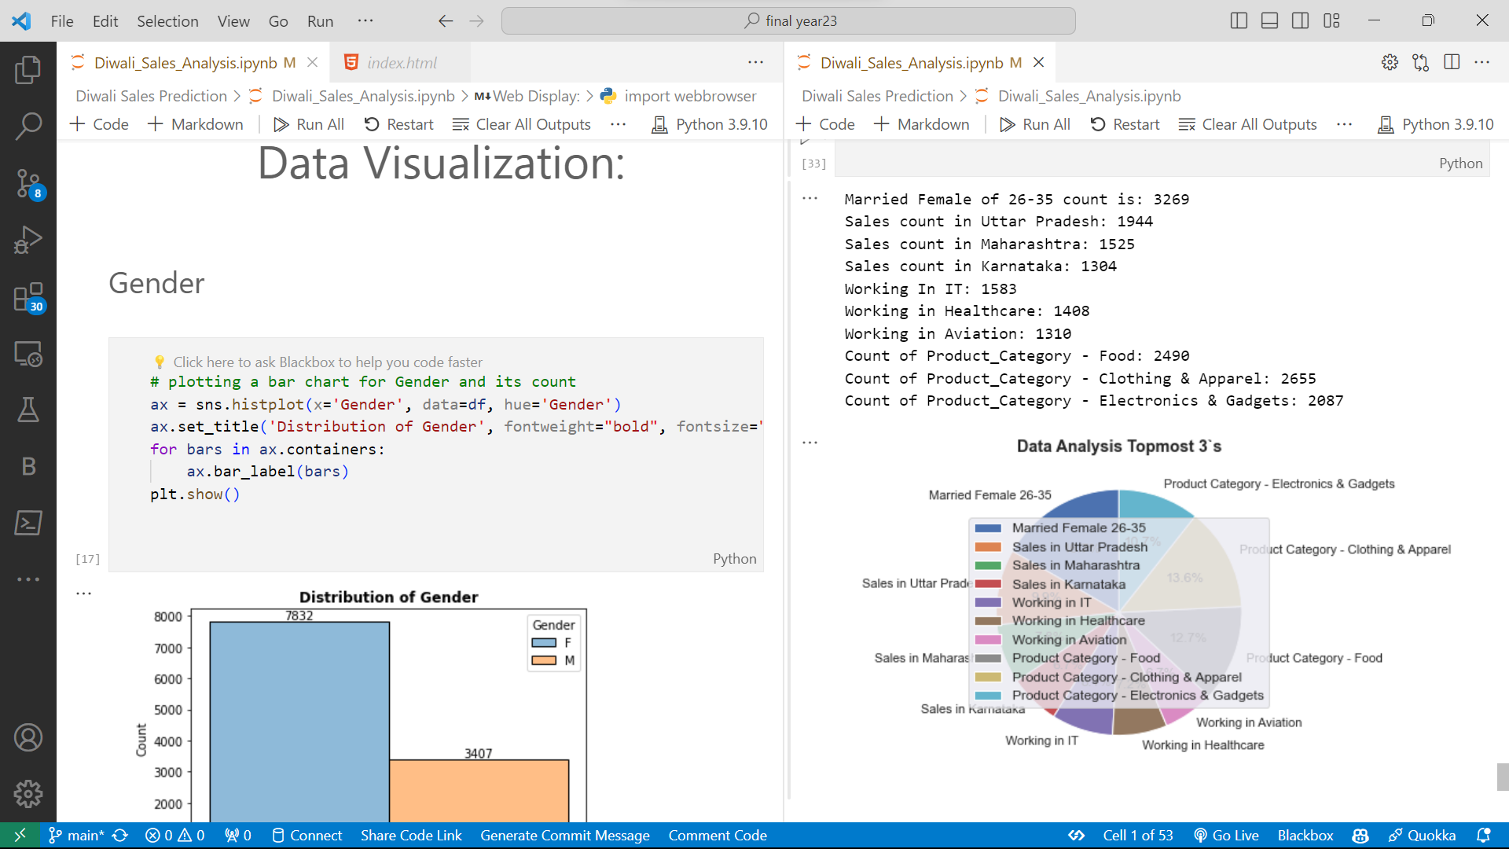**Data Visualization:**

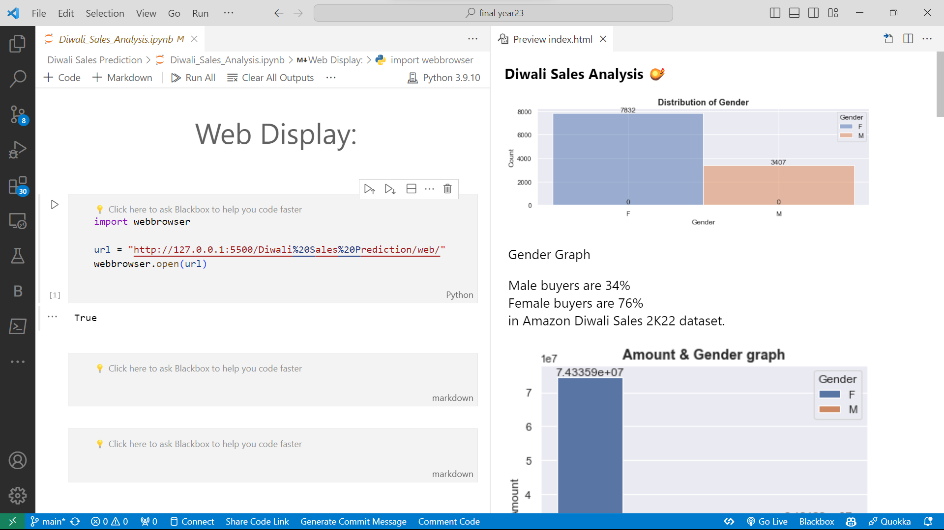**Web Display:**

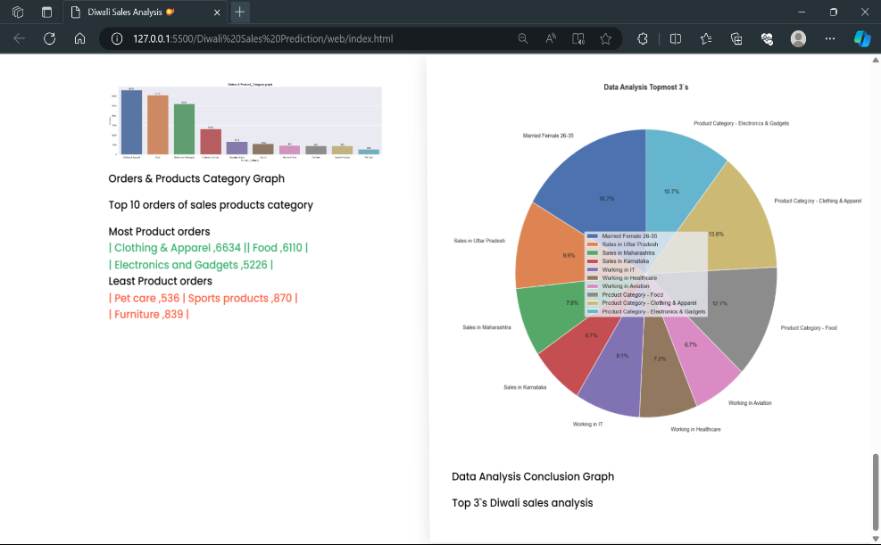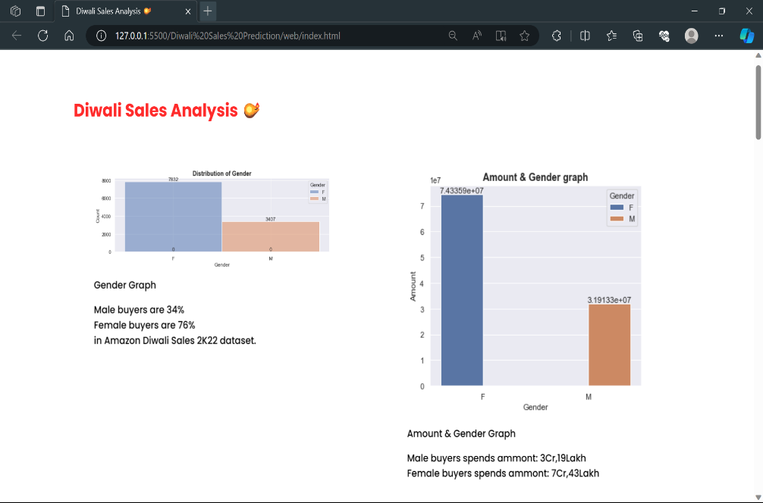

**10. Bibliography:**

* Bootstrap for designing ( [Introduction · Bootstrap v5.0 (getbootstrap.com)](https://getbootstrap.com/docs/5.0/getting-started/introduction/) )
* Kaggle for dataset ( [Diwali Sales Analysis (kaggle.com)](https://www.kaggle.com/datasets/shukla39/diwali-sales-analysis) )
* Official Pandas documentation for project dataframe ( [User Guide — pandas 2.1.4 documentation (pydata.org)](https://pandas.pydata.org/docs/user_guide/index.html) )
* Official matplotlib documentation for project graphs ( [Using Matplotlib — Matplotlib 3.8.2 documentation](https://matplotlib.org/stable/users/index) )
* Official seaborn documentation for project charts ( [User guide and tutorial — seaborn 0.13.1 documentation (pydata.org)](https://seaborn.pydata.org/tutorial.html) )
* Official copilot documentation for project ( [Step-by-Step: How to Setup Copilot Chat in VS Code (microsoft.com)](https://techcommunity.microsoft.com/t5/educator-developer-blog/step-by-step-how-to-setup-copilot-chat-in-vs-code/ba-p/3849227) )